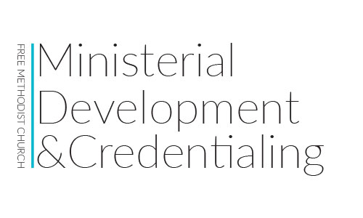

**LMC Theological Proficiency Assessment**

|  |
| --- |
| 1. List 7-10 significant Old Testament events, in chronological order, and briefly explain why each is important. |
| 1. List 7-10 significant New Testament events and briefly explain why each is important. |
| 1. In 100-200 words, explains what Christians mean when they describe the Bible as “God’s inspired Word.” |
| 1. What genres, or types of literature, do we find in Scripture? Why does knowing this matter? |
| 1. Below are statements future congregants might say to you. Please write a 100-200 word response to each. |
| 1. Jews, Muslims, and Christians all serve the same God. |
| 1. If someone isn’t healed, it’s because they lack faith. |
| 1. Although the Old Testament provides useful background for the New Testament, it isn’t relevant today. |
| 1. Since Jesus said the poor will always be with us and most of them are poor because of bad choices they’ve made, I shouldn’t bother with them. |
| 1. Jesus was a really good person, or maybe a prophet, but he wasn’t the Son of God. |
| 1. Scripture forbids baptizing infants. |
| 1. The Bible prohibits women from leading in the Church unless they have the covering of a man. |
| 1. Speaking in tongues is proof that someone has received the gift of the Holy Spirit. |
| 1. The King James Version is the only accurate version of the Bible. |
| 1. If I make a decision to accept Christ, I am certain to go to heaven regardless of how I live my life. |
| 1. If my good works outweigh my sins, God will accept me into heaven. |

|  |
| --- |
| 6. In 100-200 words, how would you explain salvation to someone who asked about it? |
| 7. In 100-200 words, how would you explain the role of the Holy Spirit to someone who asked? |
| 8. In 100 words or less (each), explain why the following groups/people are important to our history as Free Methodists: |
| * The Early Church |
| * Martin Luther |
| * John Wesley |
| * B.T. Roberts |
|  |
| 9. In addition to those listed in #5, what are some other common false beliefs you have heard, inside or outside of the Church? How would you respond to them? |
| 10. What two sacraments does the Free Methodist Church recognize? |
| 11. How would you explain the following theological terms to your (future) congregation? If you quote another source, please cite it. |
| * Salvation |
| * Justification |
| * Regeneration |
| * Sanctification |
| * Glorification |
| 12. Why does it matter to know what these terms mean? |