The Harvest Conference of the Free Methodist Church
The Harvest Conference | 300 S Walnut Lane suite 402 beaver, pa 15009
Dinner Church
A Different Kind of Church
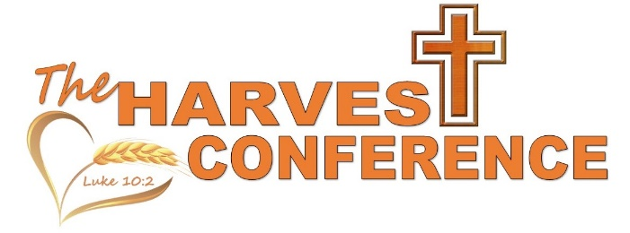

Table of Contents

A Brief History Of Dinner Church 2
Notes From Detroit Dinner Church 3
Rochester’s Adaptation 4
Covid-19 Safety 4

A Brief History of Dinner Church

The Dinner Church Collective grew out of the work of Verlon and Melody Fosner, the leaders of the first Dinner Church. Verlon spent years studying how the Apostolic-era church gathered, shared life, and made disciples around shared meals. This became his inspiration for doing church differently in order to reach the ones who most needed it. Dinner Church is about ministering to the whole person in tangible ways, not just ministering to the mind.

The simplicity of the Dinner Church model makes it easy to replicate; put on a dinner, lead a liturgy/devotional, and talk to people at the table. Part of the vision of Dinner Church is a desire to see the gospel as both proclamation and social engagement.

Passages like Luke 5 show how Jesus built his band of disciples by eating meals with outcasts and John 13-17 demonstrates how he used the dinner table to teach about the Holy Spirit. The early church followed the example of Jesus by creating “Agape” feasts where the poor and outcast could gather at an abundant table, eat a meal together, share stories and talk about Jesus.
For more about the Dinner Church origins, a resource link for books, videos, and downloads please visit http://dinnerchurch.com/resources/

The resources and events of the Dinner Church Collective will:

- Reintroduce you to dinner table theology: the way Jesus, the first Apostles and the early church encountered God together.
- You will come to understand how these dinner table experiences can make new disciples in places where other forms of churches have struggled or failed.
- Explain how others are starting unique church communities around the country.
- Provide you with tangible, step-by-step directions that will help you discover neighborhoods that need a dinner church, how to raise awareness of your new gathering and even recipes that you can use to feed a crowd.

Notes from Detroit Dinner Church
Within the Free Methodist denomination, the first to blaze the trail of Dinner Church was Mark Cryderman of Detroit. Mark is passionate about helping people do ministry in relational ways, and with food as a great common denominator in all of mankind, dinner church seemed like a great opportunity to reach people who would not typically be comfortable coming to a Sunday morning service.
Prior to Covid-19 Mark was meeting every week, either outdoors (weather permitting) or in a rented space, feeling that hosting the meal in a church could be off setting to some.
Like the original Dinner Church, the plan is simple:
- Advertise a free meal and devotional to a community (this works best in low-income urban or rural areas where people sometimes struggle for meals)
- Allow 15 – 30 minutes for people to settle in and find seats, this is typically where the worship music portion of the service would be, whether live folks singing or just a cd or iPod
- Then the meal is served (typically buffet style, with the servers being volunteers found to be in good relationships with Christ)
- Pray over the meal and then begin the liturgy or devotional as the people eat.
- Volunteers should be the last to get plates and will join the guest with at least one volunteer per table, this is so they can direct the conversations at the conclusion of the message in spiritual directions.
- When the meal is completed everyone helps to clean up, leftovers are distributed, and everyone says their good-byes.
- In order to support a dinner church that operates like this, donations of time, food, and tithes are necessary, as well as grants, and the support of other churches as a mission’s gift.

Rochester’s Adaptation
In the Harvest Conference, Rochester was the first of our churches to attempt to adapt this ministry. Some of their adaptions are as follows:
- As Rochester already had established relationships within the community as a food distribution point, they were able to use those connections to spread the word about this new food ministry. The food that is cooked and pre-packed by Rochester’s volunteers is provided through a previously established relationship with a local food bank.
- Rochester holds their weekly service in the fellowship hall of the church eliminating the need for funds to cover space rental.
- Rochester doesn’t send around an offering plate, instead choosing to leave a basket there for those who would like to give and are able too.
- Dinner Church is considered an extension of Rochester’s food ministry and therefore guest are registered with a mailing list, checked in when in attendance to either food related event and are sent monthly menus as reminders.

Covid-19 Safety

Like most things, Covid-19 changed how dinner church had to be done in order to keep people safe. Whether outdoors or in it became necessary to social distance groups by a minimum of at least 6ft and require everyone to wear mask.

Additional changes to dinner church included eliminating the buffet style of serving and taking prepared plates to the guest, as well as either water or coffee.

Volunteers could no longer join guest at the table unless they were from the same household.

Volunteers were required to wear gloves regardless of whether or not they were cooking or serving food and asked to sanitize whenever they changed gloves.

Utensils, spices (such as salt or pepper), and condiments were no longer to be left out and accessible to guest. If offered at all they needed to be pre-packaged and individual.

Guest are no longer helping in clean up, but are dismissed first and then the volunteers are cleaning up afterwards to ensure things are sanitized properly.

In the case of restaurant closures, dinner church also closes, but if take out is permitted then that can be done with dinner church as well, so long as the food is all pre-packaged and those distributing it are masked and gloved.

